Lab: Managing data
Goal: in this lab we’ll add the full CRUD (Create Read Update Delete) functionality to our API and validate the input

Adding data
Up until now, we’ve only retrieved data from our Pies API, using HTTP GET.
To Add data we’ll use the HTTP POST verb and pass the data to be added as a JSON payload to our request.
Steps:
- Add the CreatePie method to the controller, passing a Pie object as an argument.
Notice that instead of returning a OK result (HTTP 200-OK), we return a CreatedAtAction result, which references the GetPieById method
[HttpPost]
public async Task<ActionResult<Pie>> CreatePie(Pie pie)
{
var createdPie = await _pieRepository.AddAsync(pie);

return CreatedAtAction(nameof(GetPie), new { id = createdPie.Id }, createdPie);
}
- Test the result using our .http file
POST {{PieShopApi_HostAddress}}/Pies
Content-Type: application/json

{
"name": "Christmas pudding",
"description": "New Description"
}
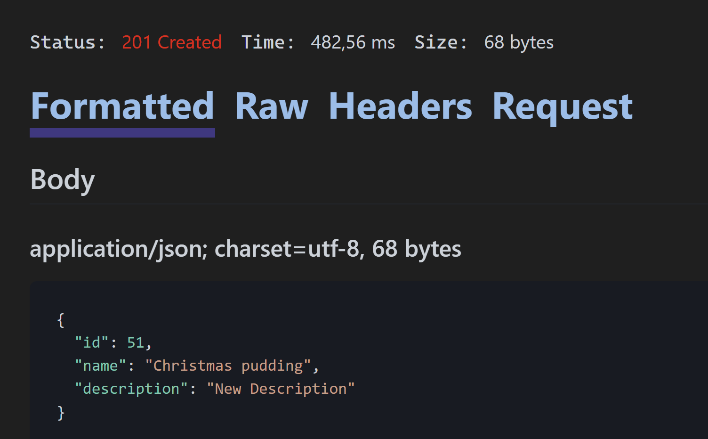
Notice the HTTP 201-Create status code and the newly created Pie with the new Id
- Still in the .http file click on the “Headers” tab of the request we just did
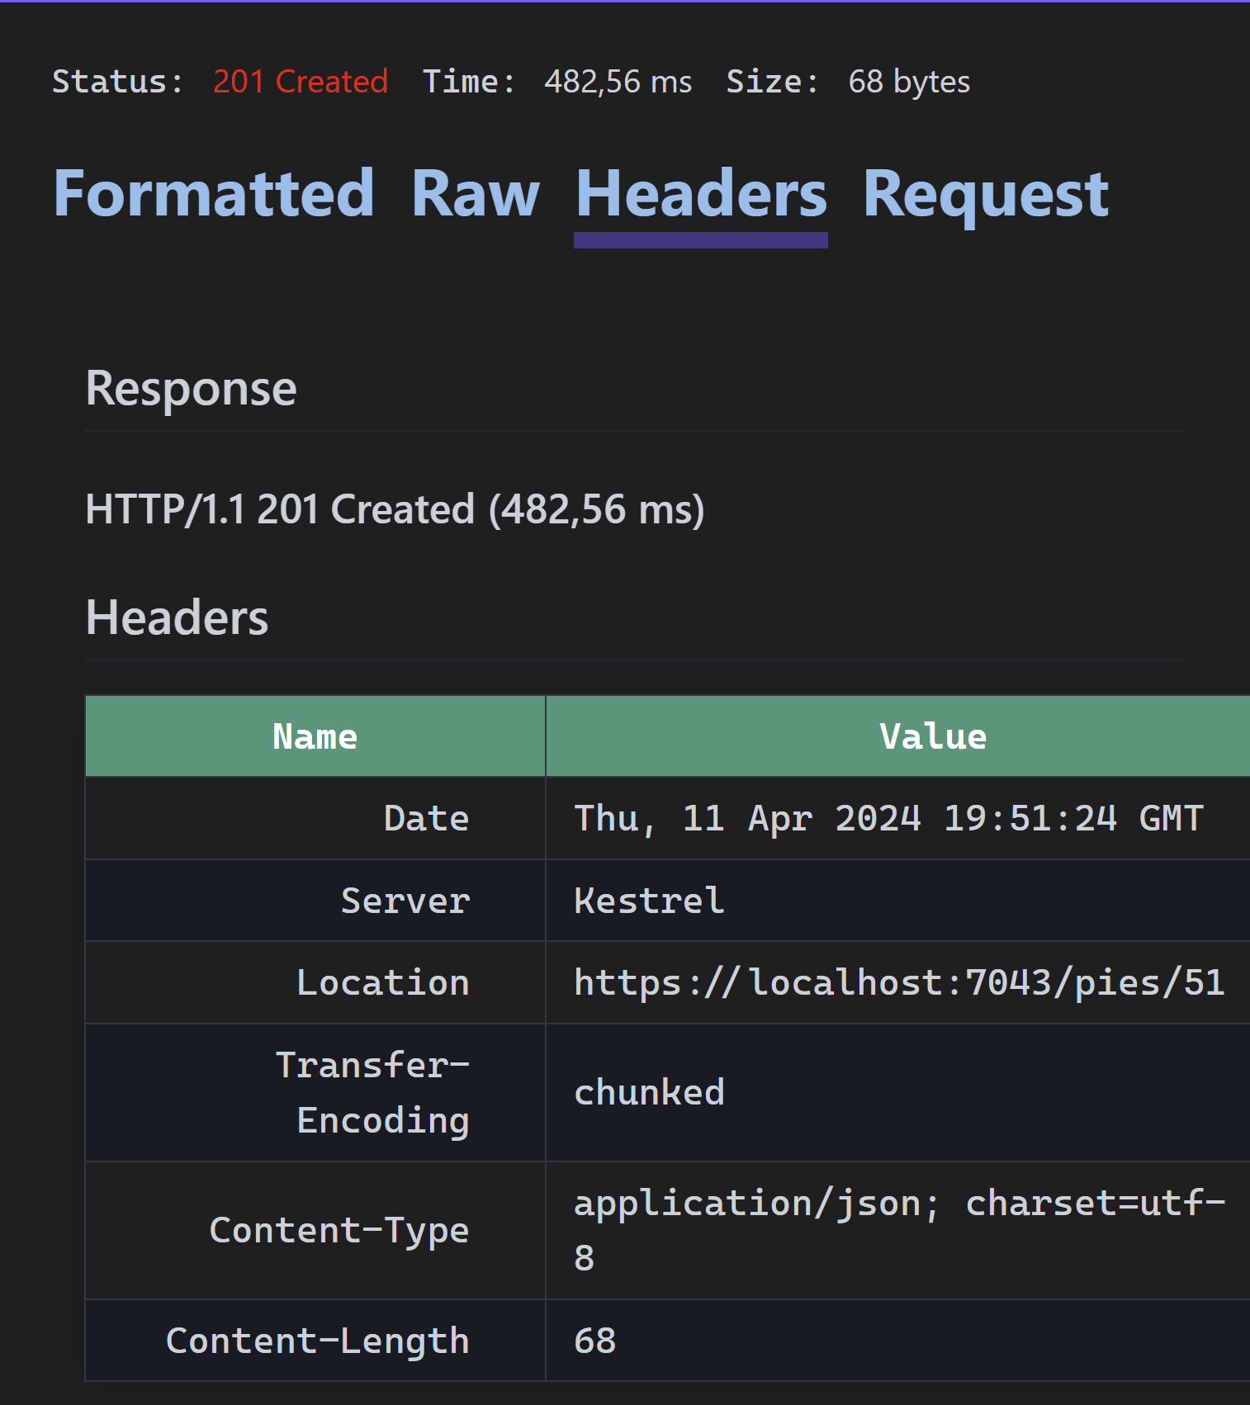
Notice the “Location” referencing the URI to retrieve our newly created Pie

Validating the input
In this part, we’ll add some validation logic, so that only Pies with the correct naming and required properties can be posted.
Steps:
Using DataAnnotations, let’s make the name required, make its allowed length between 3 and 50 characters and make the description required as well.
- Open our Pie.cs class and add the [Required] and [Length] attributes
Don’t forget to add a using statement for System.ComponentModel.DataAnnotations;
public class Pie
{
public int Id { get; set; }

[Required]
[Length(3, 50)]
public required string Name { get; set; }

[Required]
public required string Description { get; set; }
}
- Let’s test the change using our .http file by passing invalid Pies
  - Request without a Name
POST {{PieShopApi_HostAddress}}/Pies
Content-Type: application/json

{
"description": "New Description"
}
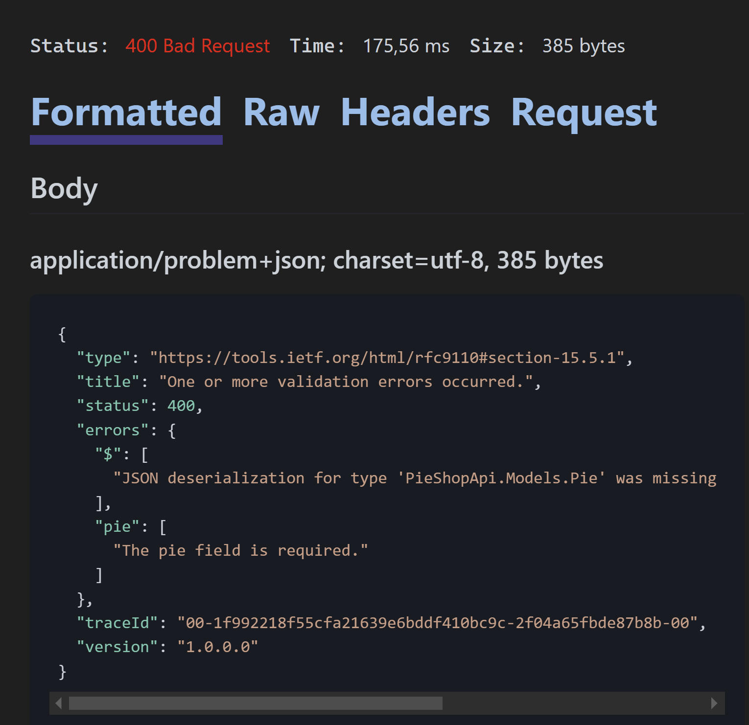
Notice the message “The pie field is required” this is not a validation error but a model binding error: ASP.NET Core is unable to bind the requested payload to the Pie class
  - Request with a Name that’s null
POST {{PieShopApi_HostAddress}}/Pies
Content-Type: application/json

{
"name": null,
"description": "New Description"
}
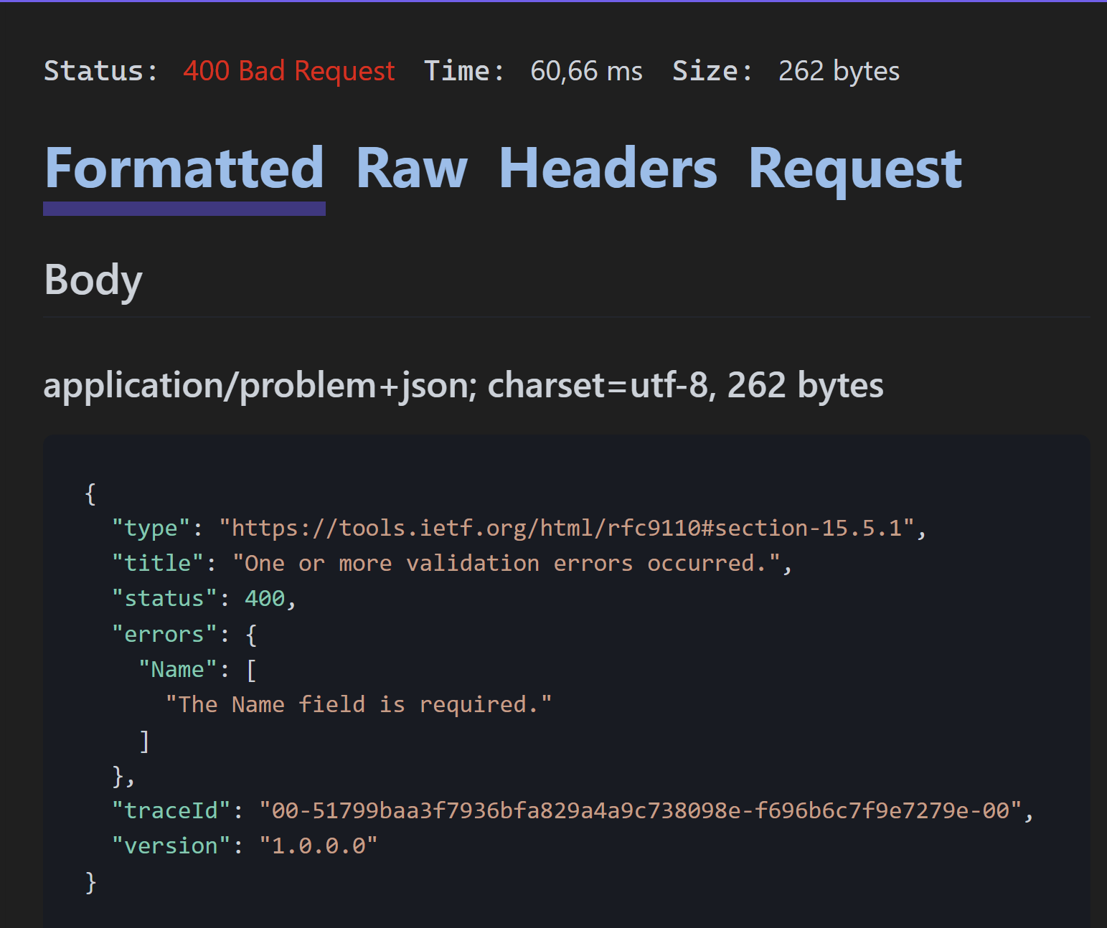
Notice the error “The Name field is required”
  - Request with a Name that’s too short
POST {{PieShopApi_HostAddress}}/Pies
Content-Type: application/json

{
"name": "pi",
"description": "New Description"
}
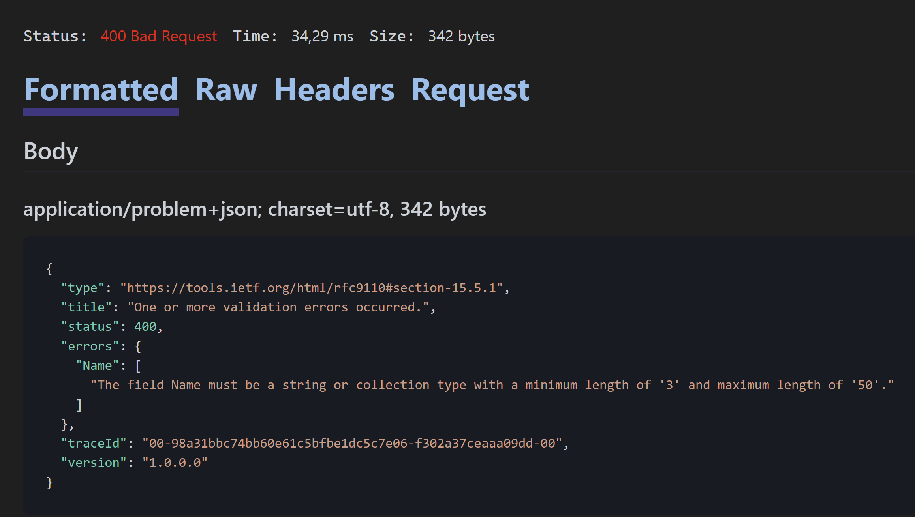
Notice the error message

Updating Data
In this part, we’ll implement the logic to update an existing Pie.
For this we’ll use the HTTP PUT method, which is used to replace an existing entity.
The request will contain the Id of the Pie we want to update, passed as a Route value to the request and the new values for the name and description properties
Steps:
- Add the UpdatePieMethod
Notice we return a Not Found result when the requested Id does not exist
Notice we return a No Content result when the update succeeds
[HttpPut]
[Route("{id:int}")]
public async Task<ActionResult<Pie>> UpdatePie(int id, Pie pie)
{
var currentPie = await _pieRepository.GetByIdAsync(id);

if (currentPie == null)
return NotFound();

currentPie.Name = pie.Name;
currentPie.Description = pie.Description;

await _pieRepository.UpdateAsync(currentPie);

return NoContent();
}
- Let’s test the UpdatePie method using our .http file
PUT {{PieShopApi_HostAddress}}/Pies/1
Content-Type: application/json

{
"name": "update pie",
"description": "New Description"
}
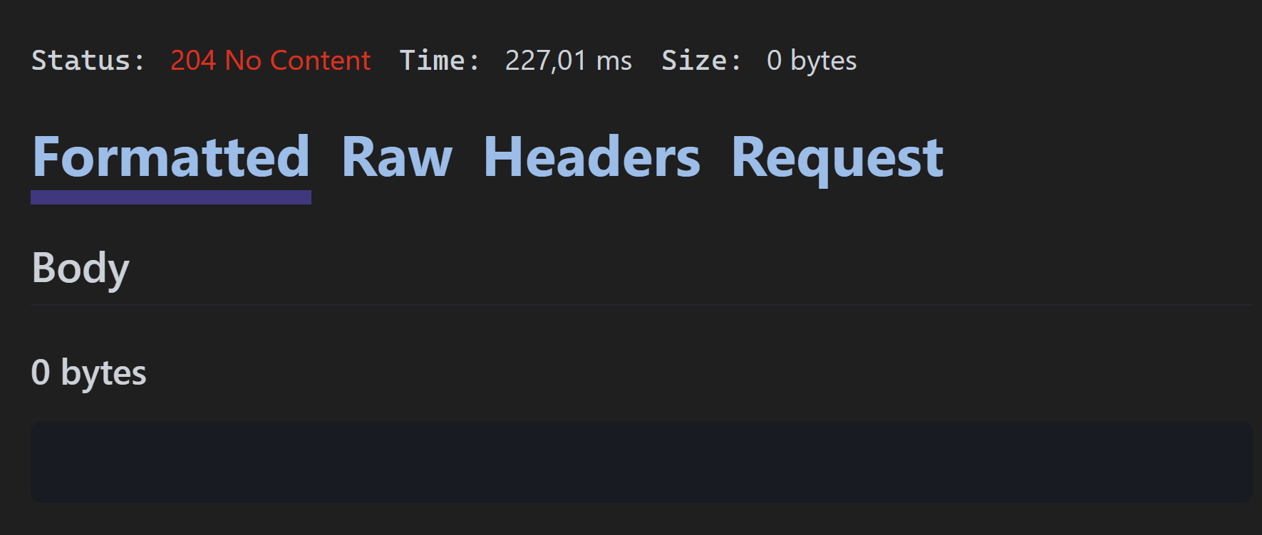
Notice the 204-No Content status code
- Retrieve the update Pie using our .http file and see if the changes took effect
GET {{PieShopApi_HostAddress}}/Pies/1
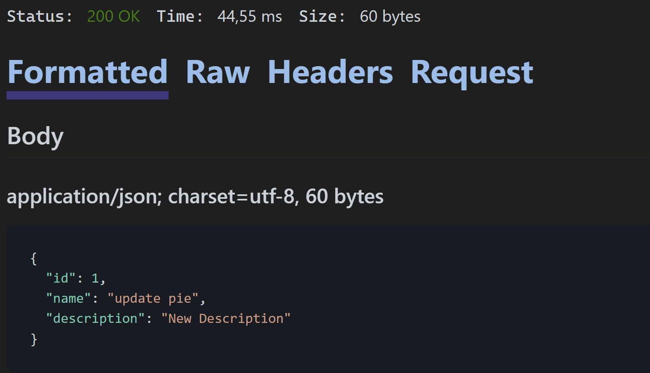
Notice the updated name and description
- Test updating an unexisting Pie (id = 999), using the .http file
PUT {{PieShopApi_HostAddress}}/Pies/999
Content-Type: application/json

{
"name": "update pie",
"description": "New Description"
}
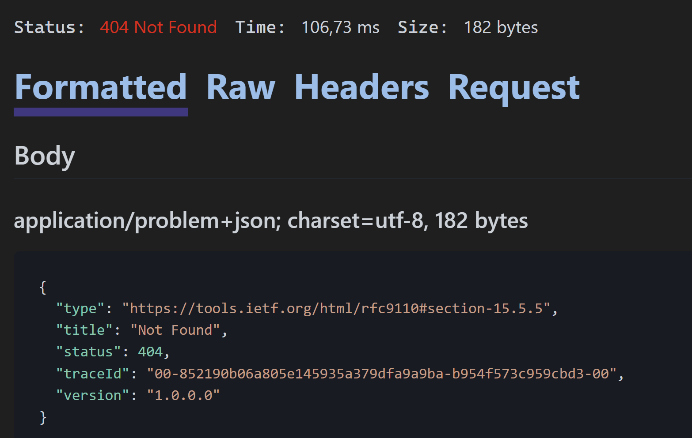
Notice the 404-Not Found
- Our DataAnnotations should also be applied for our update method, let’s test this
PUT {{PieShopApi_HostAddress}}/Pies/1
Content-Type: application/json

{
"name": "pi",
"description": "New Description"
}
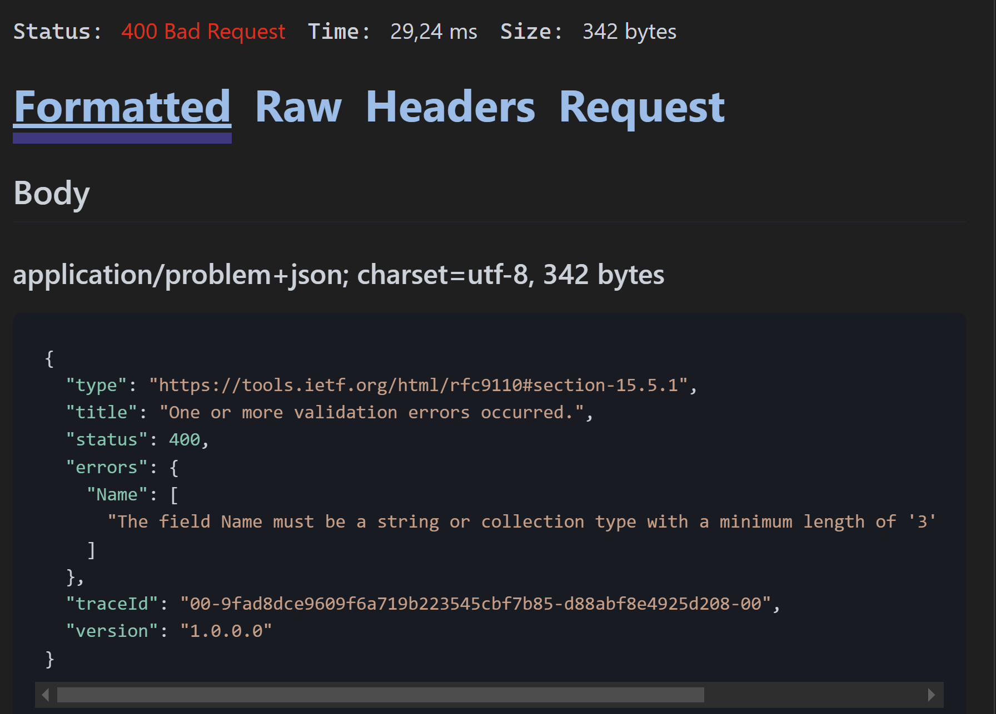
Notice the 400-Bad Request

Deleting Data
Deleting data is done with the HTTP DELETE verb, passing in the Id of the entity as a route value
Steps:
- Add the DeletePie method to the controller
Notice the Not Found return type when we try to delete an unexisting Pie and the No Content result when the delete was successful
[HttpDelete]
[Route("{id:int}")]
public async Task<ActionResult> DeletePie(int id)
{
var pie = await _pieRepository.GetByIdAsync(id);
if (pie == null)
{
return NotFound();
}

await _pieRepository.DeleteAsync(pie);

return NoContent();
}
- Let’s test the delete method using our .http file
DELETE {{PieShopApi_HostAddress}}/Pies/1
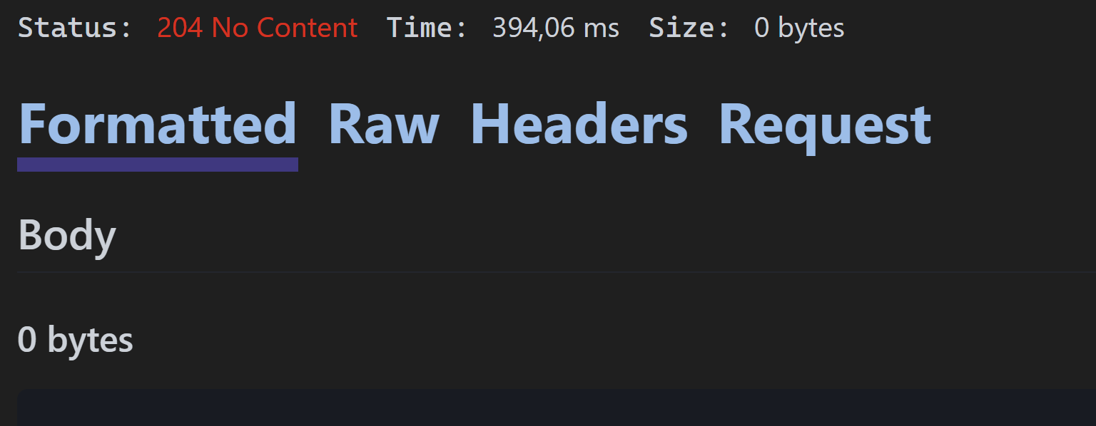
Notice the 204-No Content
- Let’s try to fetch the just deleted Pie
GET {{PieShopApi_HostAddress}}/Pies/1
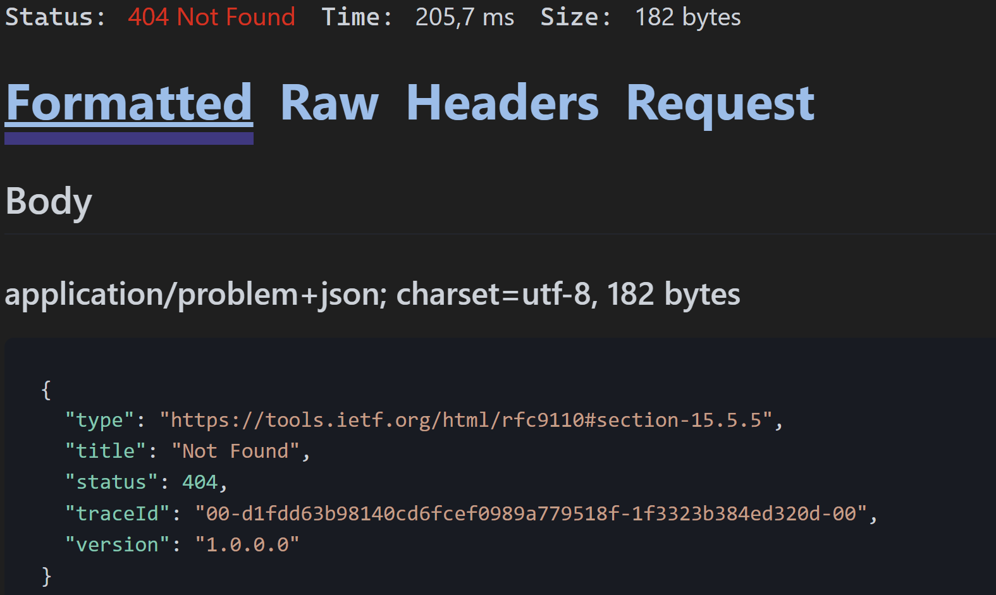
Notice the 404-Not Found
- Let’s try to delete an unexisting Pie
DELETE {{PieShopApi_HostAddress}}/Pies/999
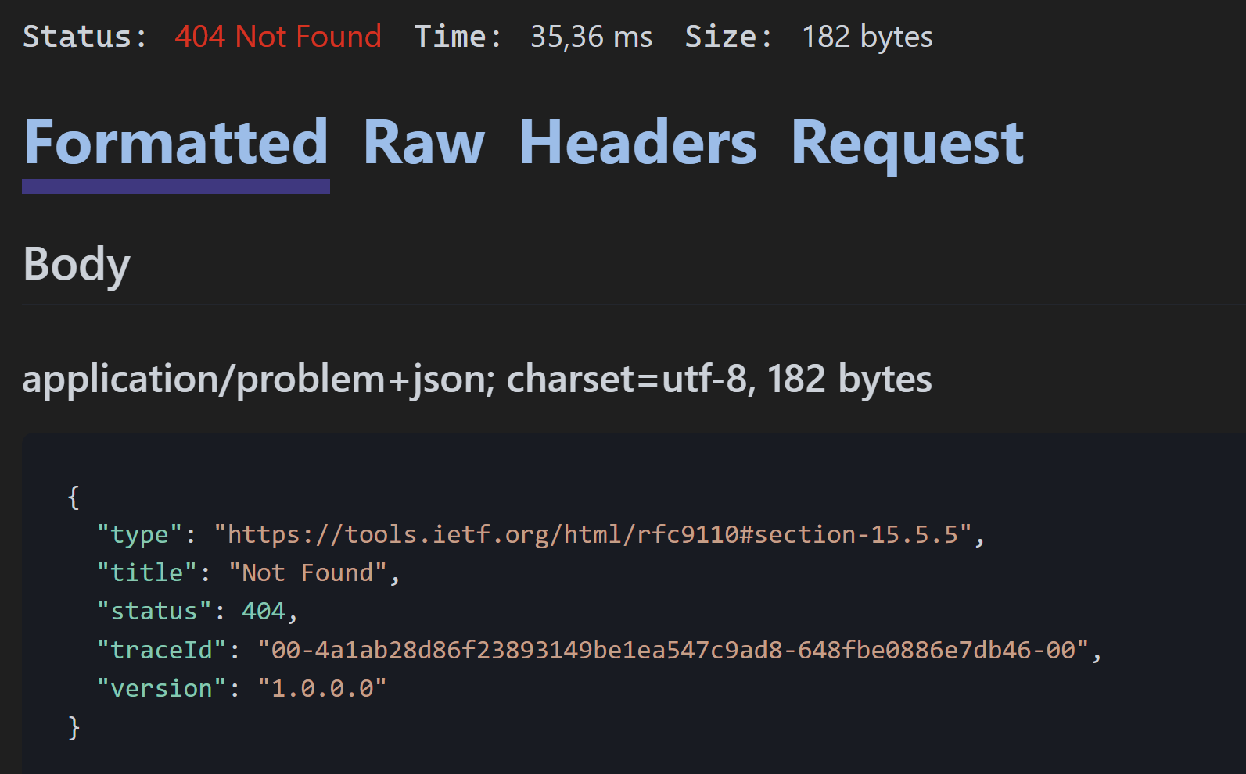
Notice the 404-Not Found

